**DAILY ONLINE ACTIVITIES SUMMARY**

|  |  |  |  |  |  |
| --- | --- | --- | --- | --- | --- |
| **Date:** | **01-06-2020** | | | **Name:** | **Latika Kavoor** |
| **Sem & Sec** | **4th Sem & A-Section** | | | **USN:** | **4AL18CS035** |
| **Online Test Summary** | | | | | |
| **Subject** | | **MATHS** | | | |
| **Max. Marks** | | **30** | | **Score** | **29** |
| **Certification Course Summary** | | | | | |
| **Course** | **BOT Aspirant** | | | | |
| **Certificate Provider** | | | **AUTOMATION ANYWHERE** | **Duration** | **12hrs** |
| **Coding Challenges** | | | | | |
| **Problem Statement:**Given an array of positive integers. Write a C Program to find the leaders in the array | | | | | |
| **Status: Completed** | | | | | |
| **Uploaded the report in Github** | | | | **Yes** | |
| **If yes Repository name** | | | | <https://github.com/alvas-education-foundation/latika.kavoor/tree/master/coding_solutions> | |
| **Uploaded the report in slack** | | | | **Yes** | |

Online Test Details: (Attach the snapshot and briefly write the report for the same)

Maths Test 3 was conducted today from 9:30am. There were two parts in it. 1 part was for 10 questions 1 mark each and the other one was for 10 question and 2 marks each.

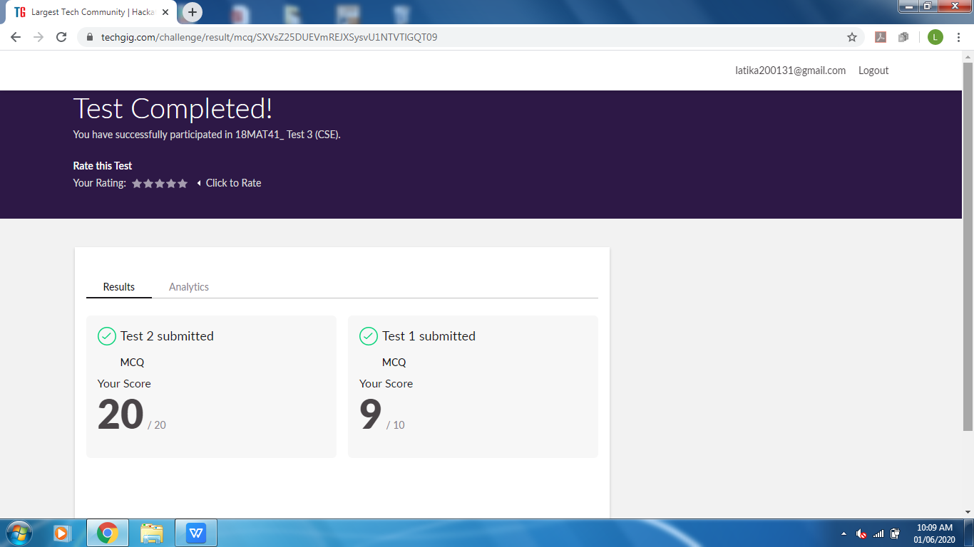Certification Course Details: (Attach the snapshot and briefly write the report for the same)

Completed the course

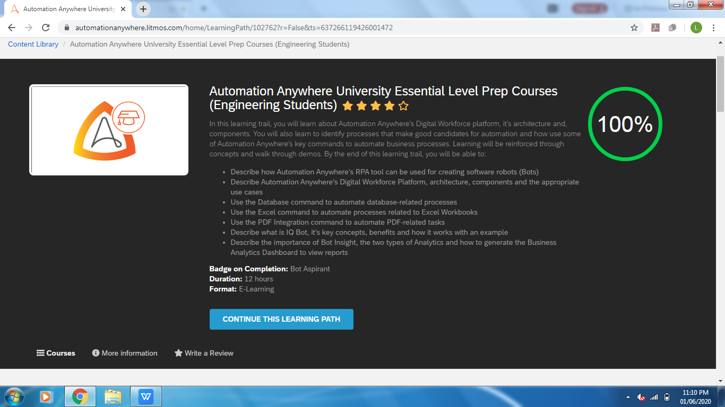

I got certificates as well of the course. It is in parts and based on modules I completed.

The link is: <https://automationanywhere.litmos.com/achievements>

I have uploaded 2 certificates rest are in my AUTOMATION ANYWHERE UNIVERSITY PROFILE

Coding Challenges Details: (Attach the snapshot and briefly write the report for the same)

Solved the problem and uploaded the same on github

